22.30: Given edge length 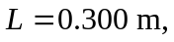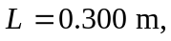and 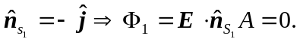
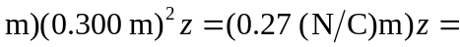
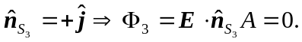
b) Total flux:
